Myfleet Test Automation

Contents

1. ABOUT THIS DOCUMENT 2

2. GLOSSARY OF TERMS 2

3. INTRODUCTION TO PROJECT 2

4. PROJECT LEVEL PRE-REQUISISTES 3

5. AUTOMATION SCOPE DETAILS………………………………………………………….4

6. SME DETAILS…………………………...…………………………………………………. 5

7. AUTOMATION FRAMEWOK…………………………..………………………………….6

8. AUTOMATION DESIGN PROCESS………..……………………………………………..10

9. AUTOMATED SCRIPTS EXECUTION PROCESS…………………………………….....12

10. REFERANCE TEMPLATES……………………………..…………………………………13

11. DOCUMENT VERSION CONTROL TABLE……………………………………………..13

# ABOUT THIS DOCUMENT:

This is an internal document between two GE entities – The Corporate Testing COE and GE Power COE. It also explains about GE Power Project Myfleet Test Automation and the roles & responsibilities of the tester. This document will assist the automation resource, who is going to work on preparation, design/maintenance & execution of existing and future scripts.

# INTRODUCTION TO PROJECT:

|  |  |
| --- | --- |
| **Project Name** | Test Automation -Myfleet |
| **GE Business** | GE Power |
| **GE Leader in Business** | Jadhav , Sheetal |
| **GE Leader in TCoE** | Ohlan , Meenakshi |
| **GDC Lead** |  |
| **No.of.Scripts In-Scope for Automation Design** | 50 |
| **Domain** | AngularJS2 |

# AUTOMATION SCOPE DETAILS:

Below are the list of scenarios going to be automated.

|  |  |  |  |
| --- | --- | --- | --- |
| **S.No.** | **Test cases Name** | **Automation Status** | **Comments** |
| **General Contract Terms And Conditions** | | | |
| 1 | Verify the line items update in Billing Schedule table |  |  |
| 2 | Verify the Billing calculation for Contract Level |  |  |
| 3 | Verify the Billing calculation for Individual equipment level |  |  |
| 4 | Verify the relation between Fee applicable frequency & Invoicing Frequency |  |  |
| 5 | Verify the Billing calculation when Fee application frequency is "Monthly" and Invoice Frequency is "Monthly". |  |  |
| 6 | Verify the Billing calculation when Fee application frequency is "Monthly" and Invoice Frequency is "Quarterly". |  |  |
| 7 | Verify the Billing calculation when Fee application frequency is "Monthly" and Invoice Frequency is "Semi-annually". |  |  |
| 8 | Verify the Billing calculation when Fee application frequency is "Monthly" and Invoice Frequency is "Annually". |  |  |
| 9 | Verify the Billing calculation when Fee application frequency is "Quarterly" and Invoice Frequency is "Quarterly". |  |  |
| 10 | Verify the Billing calculation when Fee application frequency is "Quarterly" and Invoice Frequency is "Semi-annually". |  |  |
| 11 | Verify the Billing calculation when Fee application frequency is "Quarterly" and Invoice Frequency is "Annually". |  |  |
| 12 | Verify the Billing calculation when Fee application frequency is "Semi-annually" and Invoice Frequency as "Semi-annually". |  |  |
| 13 | Verify the Billing calculation when Fee application frequency is "Semi-annually" and Invoice Frequency as "Annually". |  |  |
| 14 | Verify the Billing calculation when Fee application frequency is "Annually" |  | Automatable |
| 15 | Verify the Invoice Date calculation when Invoicing Frequency is "Monthly" |  | Automatable |
| 16 | Verify the Invoice Date calculation when Invoicing Frequency is "Monthly" |  |  |
| 17 | Verify the Invoice Date calculation when Invoicing Frequency is "Monthly" |  |  |
| 18 | Verify the Invoice Date calculation when Invoicing Frequency is "Monthly" |  |  |
| 19 | Verify the Invoice Date calculation when Invoicing Frequency is "Quarterly" |  |  |
| 20 | Verify the Invoice Date calculation when Invoicing Frequency is "Quarterly" |  |  |
| 21 | Verify the Invoice Date calculation when Invoicing Frequency is "Quarterly" |  |  |
| 22 | Verify the Invoice Date calculation when Invoicing Frequency is "Quarterly" |  |  |
| 23 | Verify the Invoice Date calculation when Invoicing Frequency is "Semi-Annually" |  |  |
| 24 | Verify the Invoice Date calculation when Invoicing Frequency is "Semi-Annually" |  |  |
| 25 | Verify the Invoice Date calculation when Invoicing Frequency is "Annually" |  |  |
| 26 | Verify the Invoice Date calculation when Invoicing Frequency is "Annually" |  |  |
| 27 | Verify the Billing calculation with Escalation, with same rate for all billing types |  |  |
| 28 | Verify the Billing calculation with Escalation, with different rate for different billing types |  |  |
| 29 | Verify the Billing calculation when Escalation be applied as separate line in calculation |  |  |
| 30 | Verify the Billing calculation when Escalation be applied to the billing rates itself |  |  |
| 31 | Verify the Billing calculation when option "Show escalation by unit/by billing type" selected |  |  |
| 32 | Verify the Billing calculation when option "Show escalation by unit/by billing type" selected |  |  |
| 33 | Verify the Billing calculation when option "Show escalation separately for Fixed and Variable" selected |  |  |
| 34 | Verify the Billing calculation when option "Combine all escalation into one line" selected |  |  |
| 35 | Verify the Billing calculation when the billing split by Site/Equipment |  |  |
| 36 | Verify the Billing calculation when the billing split by percentage across different Project ID's |  |  |
| 37 | Fixed Billing description template |  |  |
| 38 | Variable Billing description template |  |  |
| 39 | Milestone Billing description template |  |  |
| 40 | Escalation description template |  |  |
| **Fixed Billing Terms and Conditions – Unescalated** | | | |
| 41 | Fixed billing amount for the entire contract |  |  |
| 42 | Fixed billing amount at different start and end period |  |  |
| 43 | Fixed billing amount at different Event Dates |  |  |
| 44 | Fixed billing amount to change with specified operating data ranges |  |  |
| 45 | No Fixed Billing |  |  |
| **Variable Billing Terms and Conditions – Unescalated** | | | |
| 46 | Variable billing - One rate across the entire contract timeline |  |  |
| 47 | Variable billing - Different rates across different time period |  |  |
| 48 | Variable billing - Different rates across different range of operations |  |  |
| **Milestone Billing Terms and Conditions – Unescalated** | | | |
| 49 | Milestone billing - Events based milestone billings |  |  |
| 50 | Milestone billing - Date Based Milestone |  |  |

# SME DETAILS:

|  |  |  |  |
| --- | --- | --- | --- |
| **S.No** | **Functional Area** | **First Contact (Name &SSO  id)** | **Functional Lead (Name & SSO id)** |
| 1 | Manufacturing(MF) |  |  |
| 2 | Procurement(PU) |  |  |
| 3 | Customer Service(CS) |  |  |
| 4 | Freight and Distribution(FD) |  |  |
| 5 | Finance(FI) |  |  |
| 6 | Warehouse Management(WH/WM) |  |  |
| 7 | Quality Management(QM) |  |  |
|  |  |  |  |

# AUTOMATION FRAMEWOK:

The below Process describes how to use Protractor to develop and execute Automation Scripts for Myfleet application. Step-by-step instructions provided will help you in understanding the execution flow of test scripts.

**Module Structure Details:-**

In order to maintain all the files created in automation like Configuration files, library files, Automation Scripts, Result Files etc. we would require a suitable folder hierarchy. Hence we have created a root folder for this Framework with the following folders, which is shown below screenshot.

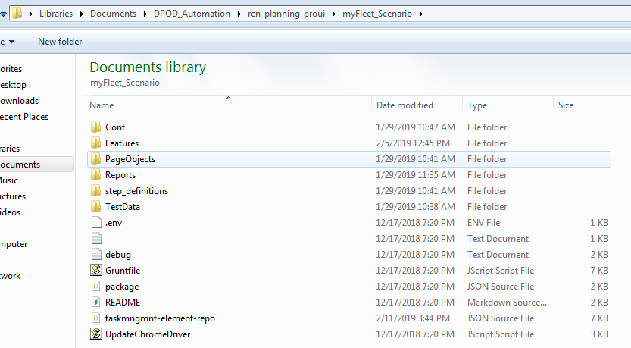

1. **Conf:** This folder contains the protractor configuration file of the test module that we are using (starting point of execution). Every module will have its own configuration file.
2. **Feature:** This folder will contain all the feature files of a module.
3. **Locators:** This folder is will contain all the json files for the modules.
4. **PageObjects:** This folder contains all the page objects created as per POM model for a module.
5. **Step_defination:** Corresponding to feature files all the step definition files will be part of this folder.
6. **TestData:** This is meant for specific test data json files, if not fulfilled in Locators folder files.

*Note:*  *Any deviation from the structure may not allow common functions to work properly.*

**Results Files:**

1. After executing the driver script from Protractor tool, the Automation Script performs the operations based on the description provided in the Manual Test Case and verifies the output of the Application against the Expected Results in the Manual Test Case. The run-time data along with the verification result will be added to actual result of Manual Test Case in step wise.

For verification purpose we have below two kinds of Results available for Each Test Script after execution

* 1. High level execution status

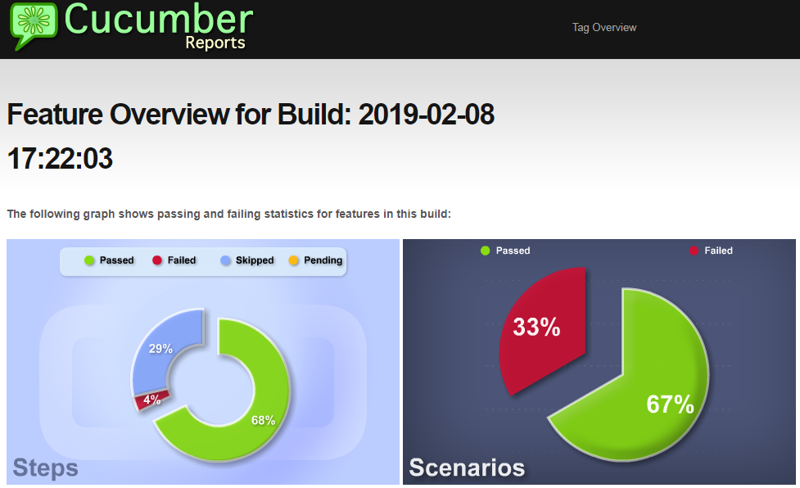

* 1. Detailed step by step Results

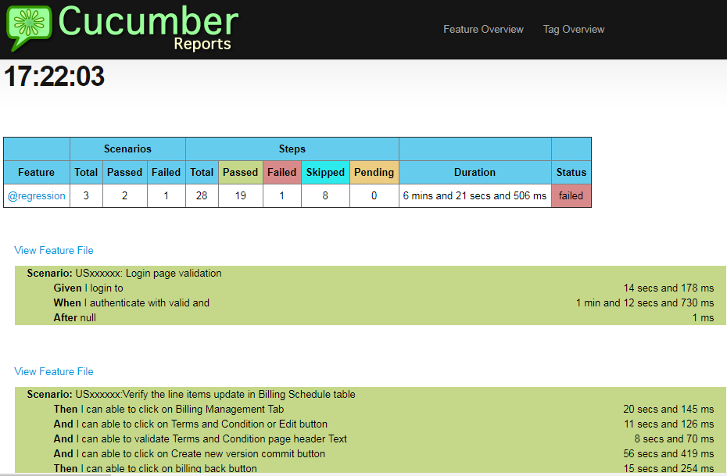

# AUTOMATION DESIGN PROCESS :

1. **Review of previous evidence reports for understanding scenario**

Automation Resource should go through the reports of previous execution done manually to understand the flow of test script.

1. **Automation feasibility analysis of Manual scripts.**

Automation Resource should analyse the test script functionality to decide whether the scenario is Automatable, Semi-Automatable or Not Automatable.

1. **Questions Preparation & Internal Review of manual test scripts eligible for Automation**

Automation Resource should prepare the list of questions on which clarification is needed from SME and should conduct an internal peer review on the analysis done for automation.

1. **Schedule meetings with SMEs for the clarification on Questions.**

Automation resource should schedule meetings with SMEs to get the clarification on the questions prepared.

1. **Ensure Test Data readiness.**

Automation Resource needs to send a mail to SMEs by requesting the Test Data required for the scenario to be automated

1. **Test Bed preparation for Automation**

As per the tool confirmation from business, Automation resource should install all the required software in his/her machine to kick-off the Automation Design

1. **Publishing script Automation Status**

Automation resource should publish a Daily status report to enable Business, stakeholders & SMEs to know the current status of Automation design

1. **Dry Run of Completed Automated Scripts**

Automation Resource should execute the initial draft of completely Automated script to make sure whether it is working as expected or not.

1. **Review of Automated Scripts**

Peer reviews should be done on the automated script to identify the errors and code Enhancements

1. **Verification Points documentation & Review**

Automation resource should document the Verification points implemented in automated script to a given template and send it to leads for Review

1. **Automated script update based on Suggestions from SMEs & Functional Leads**

Automation Resource should update the code in the automated script as per the suggestions from SMEs and Leads.

1. **Uploading Automated script**

Automation Resource should upload the Final automated script to Test plan and should complete all the approval with the help of dummy IDs provided by the business.

# AUTOMATED SCRIPTS EXECUTION PROCESS:

1. **Raising Defects for functional issue found during the Formal Run**

Automation resource should provide the necessary information to the test manger regarding the functional issue for a defect need to be raised in rally

1. **re-execution of Automated scripts after the Defect resolution**

Automation resource should re-execute the failed test scripts after the defects resolution in order to confirm the excepted functionality

1. **Ensuring the approvals of all runs by Validation Managers**

Automation resource should change the approval status of All passed runs (Automation & Manual) in Test Lab to “Ready for Approval” and inform the Validation Manager (VM) for review.

1. **Execution & Sign-Off**

Automation resource should execute the final automated script, generate the final report and sent it to the business for final Sign-Off

# REFERANCE TEMPLATES:

Below are the reference templates for Test Data & Verification point documentation.

1. Regression test cases Sheet

# Document version control table:

|  |  |  |  |
| --- | --- | --- | --- |
| **Version Control** | | | |
| **Version Number** | **Creation Date** | **Author** | **Reviewed & Approved by** |
| V1.0 | 1.02.2019 | Radha Krishna M |  |
|  |  |  |  |
|  |  |  |  |
|  |  |  |  |